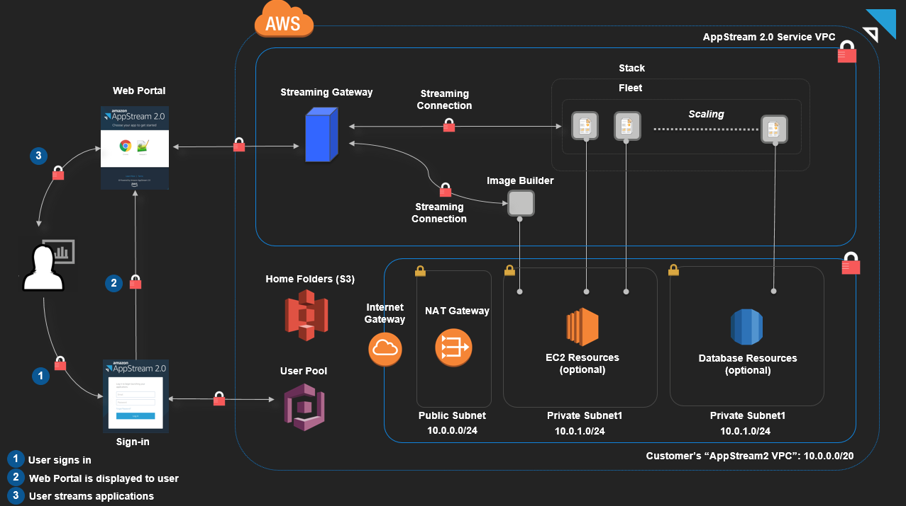

1. Use CloudFormation template to setup network environment
2. Please check the variables at top for VPC /CIDR blocks and ensure they don’t overlap with yours

\*\* These steps only need to be done to create the image that will be used

1. Create an AppStream 2.0 image builder
2. Connect to the image builder and install applications
3. Use Image Assistant to create an AppStream 2.0 image

\*\* Only these steps are needed to deploy your image (pre-built). Assumes you have classical public/private subnets in a VPC with NAT and IGW deployed.

[Warning: The image MUST be deployed to a private subnet and use NAT. It will not work if deployed to a public subnet.]

1. Provision a fleet. Start it (can take 15+ minutes)
2. Create an AppStream stack. Then associate it to the previously created fleet.
3. You now need manage access to users to the stack.

You now have (2) options:

1) Create a streaming URL by using a unique userid and picking a duration (30 secs to 7 days). With streaming URL you’re able to share the exact session they see – helpful for lab trouble-shooting.

2) Create a user in “User Pool” where they receive an email and have to login and setup username/password in Windows Appstream environment.

4/20/2020 – worked on getting VPC template to use SSM Parameter Store to pass in VPC and Subnet CIDR blocks.

* Need to get it to pass VPC ID as output for “Provision a fleet” step

(6) Provision a fleet: